Save the Date Now!
July 22, 2017
NW Therapeutic Horticulture Networking Meeting
11:00 – 1:00 Room 1075-77
Legacy Emanuel Medical Center
2801 N. Gantenbein, Portland 97212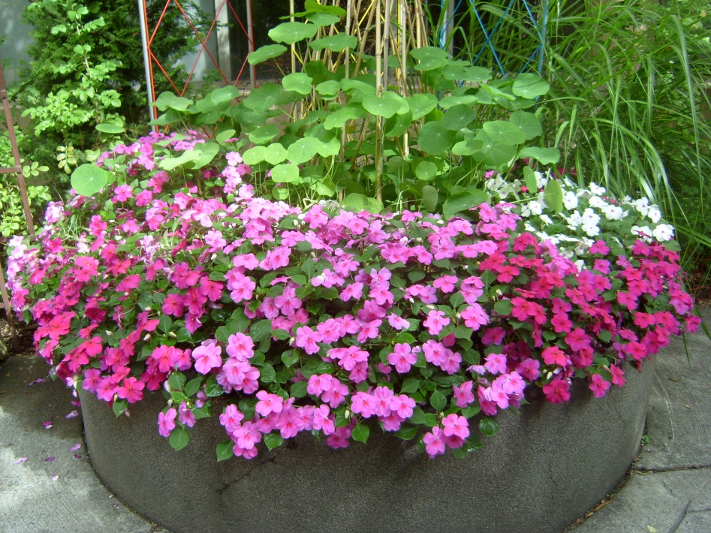
Park in any Legacy garage or on the street. Ask for room location at any Emanuel information desk.
11:00 Socializing, introductions, and sharing session plans
11:20 Welcome
11:25 AHTA Report
11:35 Program: Legacy Pediatric Nature Stations
12:10 Guided garden tours to Oregon Burn Center Garden, Family Birth-CVICU Garden and the Children’s Garden
12:50 Wrap up and announcements
1:00 Meeting concludes
Register with thazen@lhs.org with limit of 24 people. See more about the Legacy Therapeutic Garden Program at www.legacyhealth.org/gardens.

Teresia Hazen, MEd, HTR, QMHP
Coordinator, Therapeutic Garden Program
Legacy Health
1015 NW 22nd Ave Suite 529
Portland, OR 97210
503.413.6507
thazen@lhs.org
www.legacyhealth.org/gardens
Gardens for rehabilitation, recovery and restoration.

