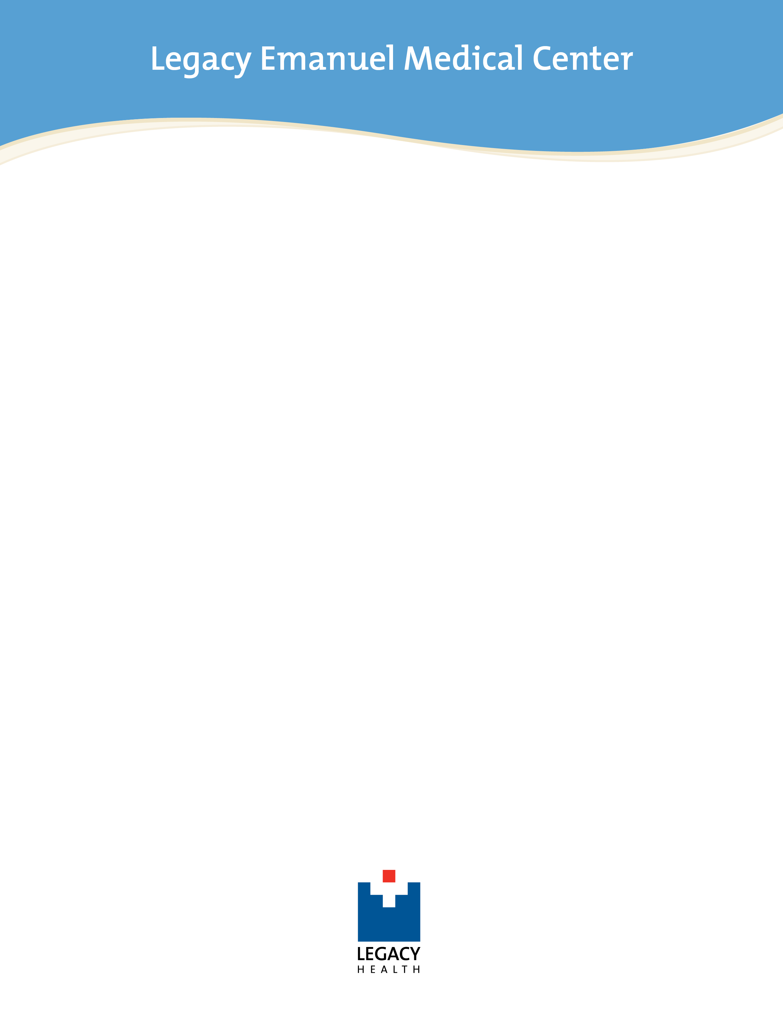
Oregon Burn Center Summer 2016

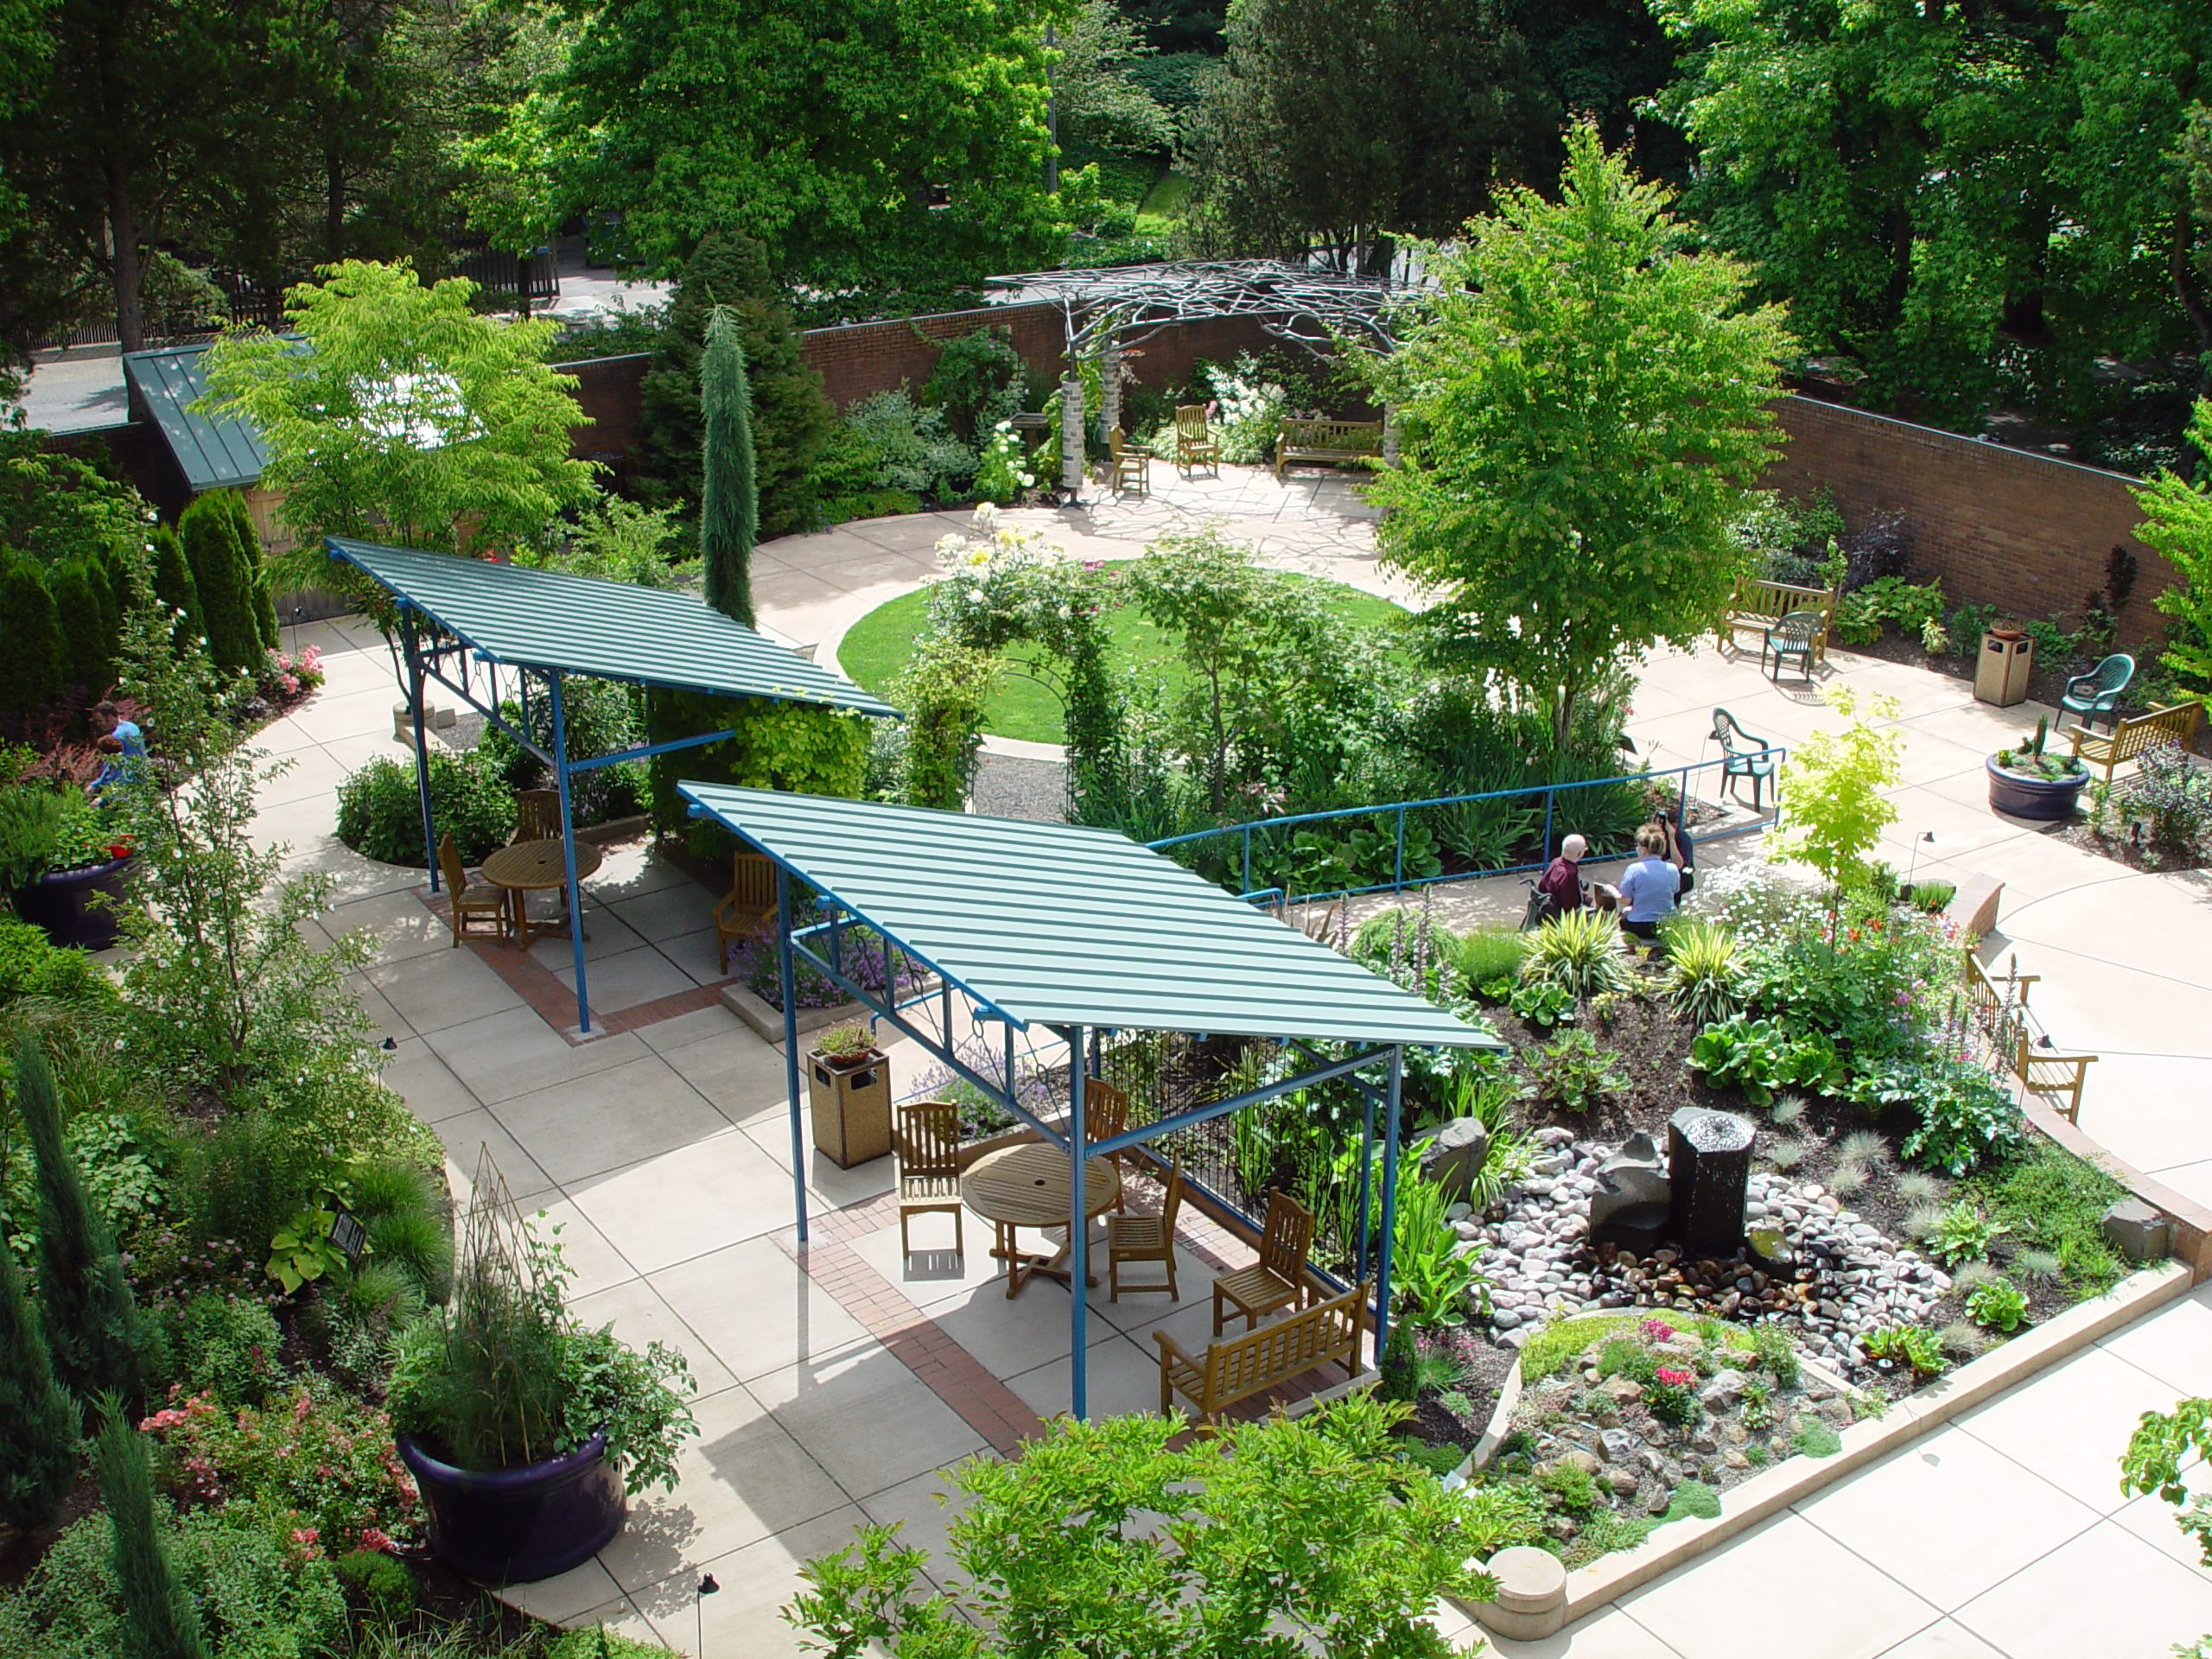
3001 N. Gantenbein, Portland 97227
Open Garden Events
11:30 a.m. – 1:00 p.m. June 8 & August 17

All community members are invited to these FREE events. Enjoy garden tours, nature activities, plant lists, live music, pet therapy, and more. Bring your lunch and enjoy a picnic in the garden. Park in the orange garage and follow the green balloons to enter through the east garden door or the accessible entrance on the south side of the garden.
Please take photos of the Legacy gardens. Out of respect and privacy needs, do not take photos of our patients and their families.
This award-winning garden was dedicated May 2004. Watch it grow, and join us every year at Summer Open Gardens. See the Oregon Burn Center Garden and all Legacy gardens at www.legacyhealth.org/gardens.

