Terrace Garden Summer 2016

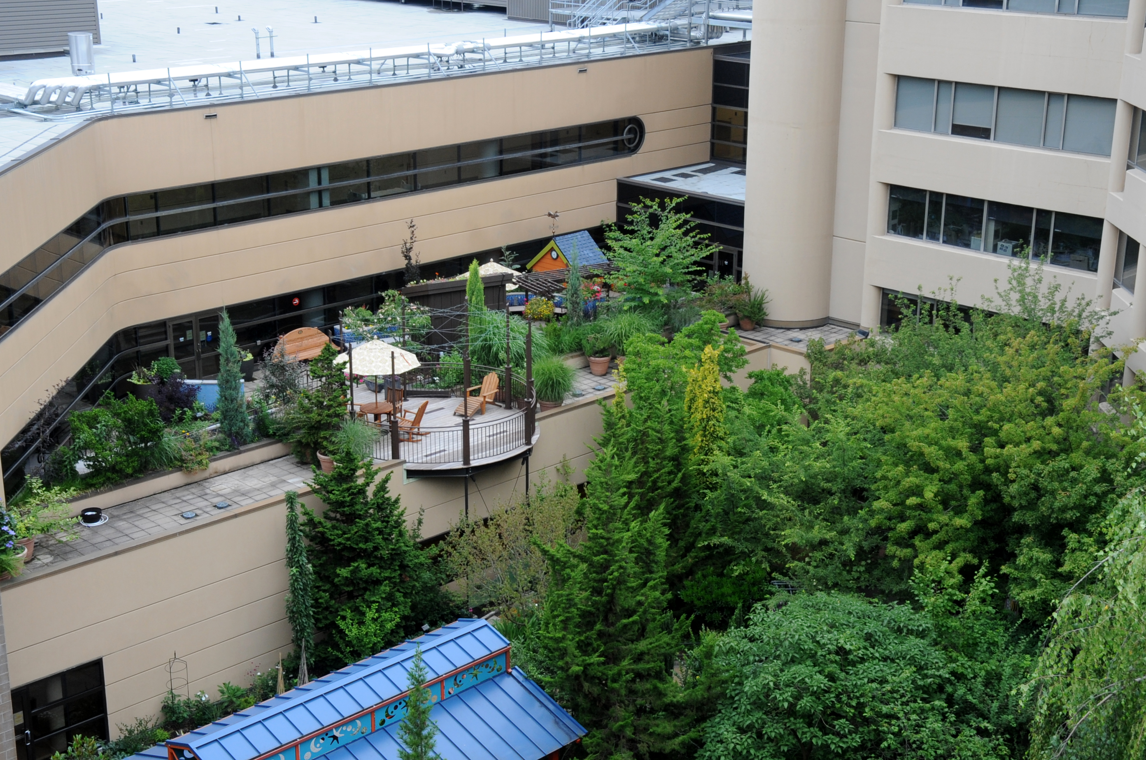
Please help us celebrate Summer in the Garden. The garden was dedicated April 14, 2014.
We are celebrating our third summer!
Join us at 2:00 – 3:30 for garden tours, music, pet therapy and nature activities.
June 22
July 20
August 31
Take a break every day in the garden!
We are located on the second floor of Emanuel Medical Center 2801 N. Gantebein www.legacyhealth.org/maps.
See more about the Legacy Therapeutic Garden program at www.legacyhealth.org/gardens, www.legacyhealth.org/gardenresearch, and
http://www.healthcaredesignmagazine.com/article/legacy-emanuel-medical-center-plants-purpose.

For more information contact thazen@lhs.org 503-413-6507.

