Legacy Health Systems
Department of Pharmacy Services

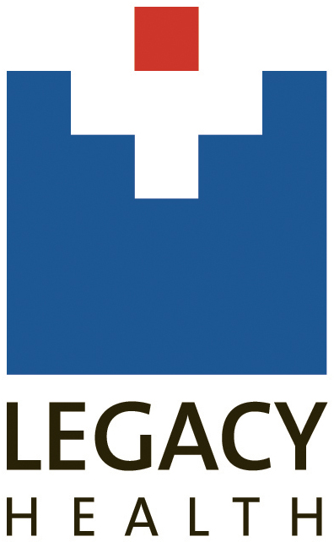

Post Graduate Year One & Two (PGY1/PGY2)
Pharmacy Residency Program
Manual 2018-2019

- Table of Contents
Legacy Health System Overview 2
Pharmacy Overview 5
Residency Program Overview 8
PGY1 Residency Program 10
PGY2 Ambulatory Care Residency Program 16
PGY2 Infectious Diseases Residency Program…………………………………………………………………………………………23
Residency Orientation 20
Resident Professional Development 21
Appendix 22

Legacy Health System Overview
Legacy Health is an Oregon-based not-for-profit, tax-exempt corporation that includes seven full-service hospitals, including a children's hospital, a full-service research facility, and a 24-hour behavioral and mental health services center. With more than 10,000 full- and part-time employees, Legacy is one of the largest private sector employers in the metropolitan area of Portland, Oregon, and Vancouver, Washington. The Legacy system provides an integrated network of health care services, including acute and critical care, inpatient and outpatient treatment, behavioral and mental health care, community health education and a variety of specialty services.
Within the system, Randall Children's Hospital is a regional leader in the care of infants, children and teens; the Legacy Oregon Burn Center is the only advanced burn care facility between Seattle and Sacramento; the Trauma Center at Legacy Emanuel has a Level I Trauma Center verified by the American College of Surgeons, the highest designation available for emergency care. Legacy also has primary care and specialty clinics, as well as hospice and laboratory services.
History
Legacy's roots go back more than 100 years. Our two largest hospitals, Good Samaritan (est. 1875) and Emanuel (est. 1912) were founded by faith-based groups seeking to care for the growing city. As the decades went on, those two hospitals grew into larger health organizations. In 1989 they merged to create Legacy Health System. Most recently, Silverton Health joined the Legacy family. Silverton Health facilities and clinics now carry the Legacy name. Legacy Health is now one of the largest private-sector employers in the Portland metropolitan area, with a service area extending north to the Vancouver area and south to the mid-Willamette Valley.

Mission & Values of Legacy Health

Our legacy is good health for:
- Our people
- Our patients
- Our communities
- Our world

We will work as a team to demonstrate our values:
- Respect - Treat all people with respect and compassion
- Service - Put the needs of our patients and their families first
- Quality - Deliver outstanding clinical services within healing environments
- Excellence - Set high standards and achieve them
- Responsibility - Be good stewards of our resources, ensuring access to care for all
- Innovation - Be progressive in our thinking and actions
- Leadership - Serve as a role model of good health and good citizenship

Pharmacy Overview
Pharmacy has a strong presence in all clinical areas within Legacy, with pharmacists decentralized in multiple patient care areas and pharmacist participation in patient care rounds. Pharmacists consult on burn unit, critical care, internal medicine, neonatal ICU, neurology/stroke, oncology, orthopedic surgery, pediatrics, transplantation, and trauma rounds.
Pharmacy protocols are established for pharmacists to manage renal dosing, warfarin, heparin, low-molecular weight heparin, antibiotics (including but not limited to vancomycin and aminoglycosides), total parenteral nutrition, stress ulcer prophylaxis, phenytoin, and therapeutic drug interchange.
Primary care clinics, transplant clinic, and anticoagulation clinics also utilize pharmacists for collaborative patient care.
Pharmacy Services operates retail outpatient pharmacies at five hospitals providing clinic, employee and discharge prescriptions.

Mission:

Legacy Pharmacy Services is committed to medication management for the safety of our patients.
“Good drugs, good people, safe patients”

Vision:
- We will use tools to ensure patient safety and quality care.
- We will be fiscally responsible.
- We will collaborate with others.
- We will support, promote and value the importance of both personal and professional priorities

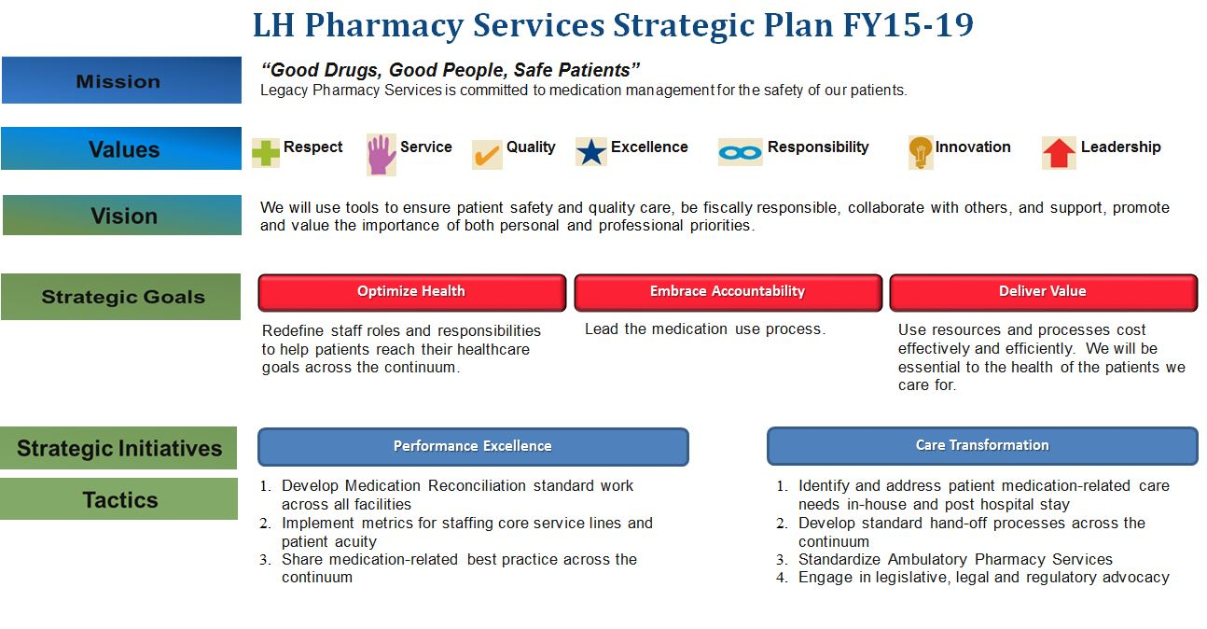

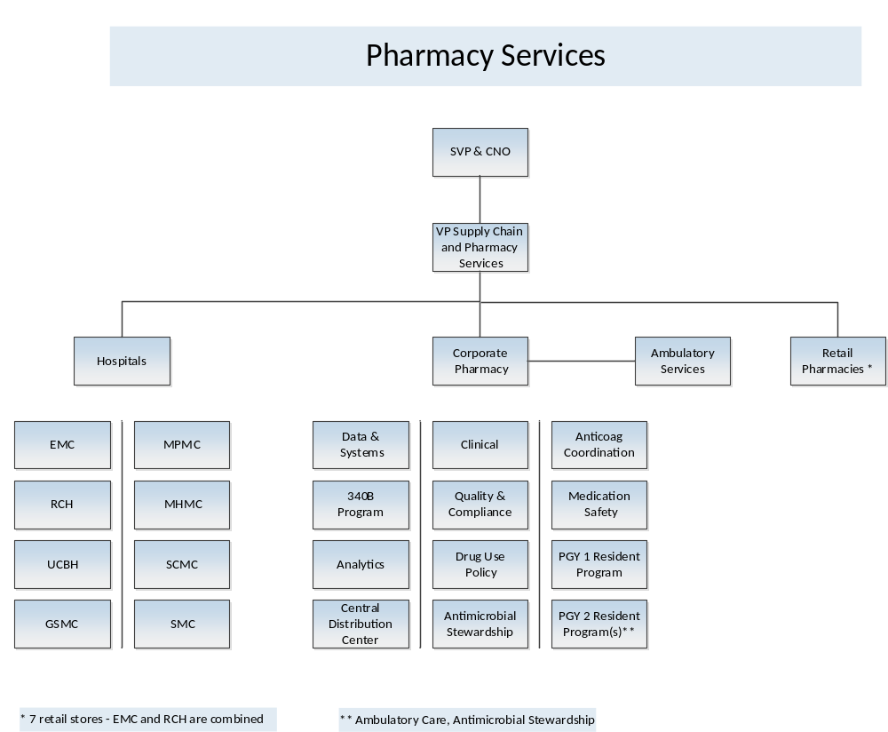
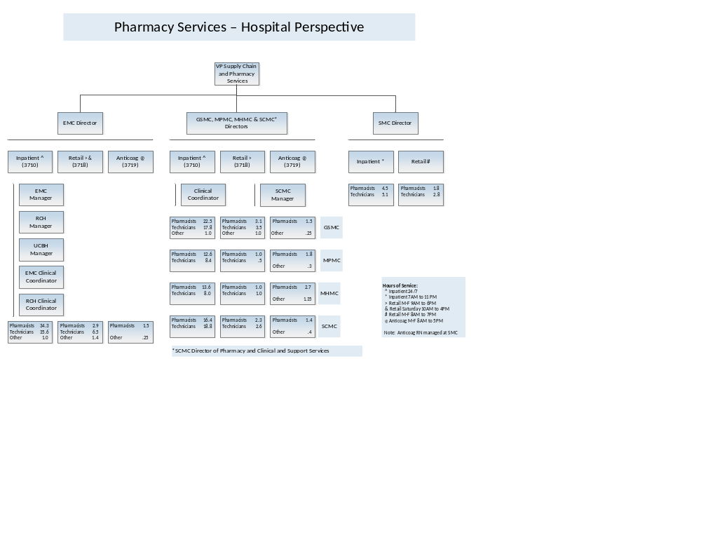
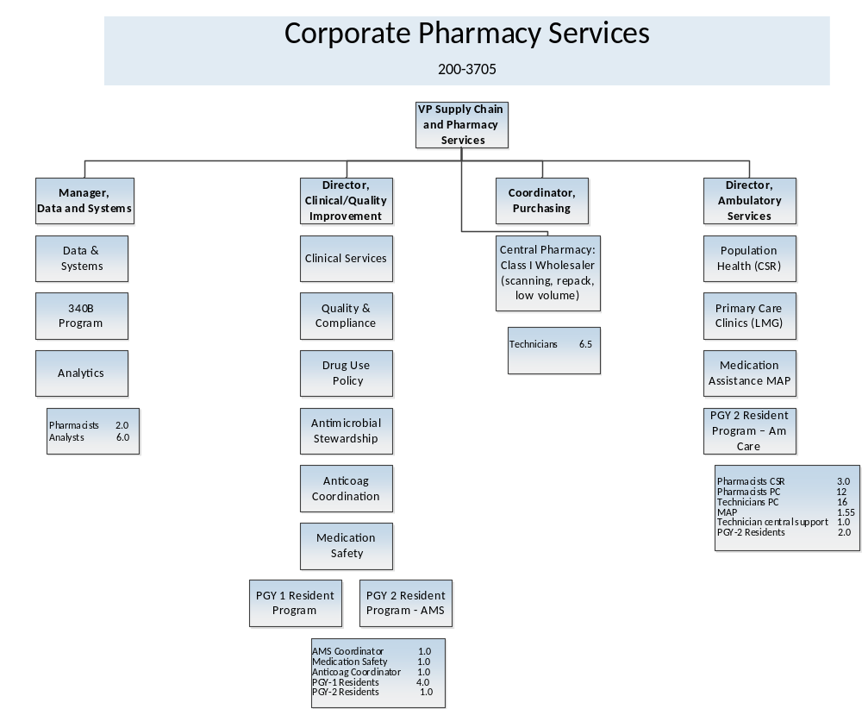

Residency Program Overview
History
Legacy Health began their pharmacy residency program in 2001 with one resident, an OSU graduate, and the program was accredited by the American Society of Health System Pharmacists in 2002. The next two residency years 2002-03 and 2003-04 also had a single resident. In 2004-05, we expanded our program to two residents and had two residents for four years. In 2008, we expanded to three residents. In 2014, we initiated our PGY2 training program with a focus on Transitions in Care. In 2017, we changed our PGY2 training program to Ambulatory Care as well as expanded our PGY1 to four residents. In 2018, we started an Infectious Disease PGY2. In 2019, we expanded our PGY1 program to a multi-site program with six residents, each based at their own individual Legacy site.
Obligations of the Resident:
- Fulfills satisfactorily, and to the best of his/her ability, the academic requirements of the training program in which Resident is enrolled.
  - General and Program Requirements are defined by the American Society of Health System Pharmacist’s PGY1/PGY2 program standards.
  - Specific educational goals and objectives for each year of residency training as defined in the resident’s individualized training plan.
  - Additional program requirements as established by the Program Director.
- Incorporates information provided through the residency program's performance evaluation process to expand his/her knowledge base and develop the skills, values and attitudes applicable to his/her level of training.
- Demonstrates knowledge of clinical pharmacy and applies this knowledge in the provision of inpatient and outpatient care, as appropriate for Resident’s level of training.
- In consideration of the patient’s needs and age, demonstrates skill in patient assessment, treatment planning, monitoring and discharge planning.
- Demonstrates competency in medical records documentation.
- Balances rotational expectations with other residency duties and clearly negotiates and communicates with rotational preceptor.
- Demonstrates good judgment in prioritizing and organizing workload to ensure timeliness of patient care.
- Fulfills any duty hours that are scheduled by Hospital and to which Resident is assigned.
- Maintains and increases medical knowledge through self-directed learning, attendance at resident conferences and meetings, and participation in professional organizations.
- Participates in committees and work groups, as assigned, and actively contributes to group problem solving.
- Provides appropriate education to patients related to medical condition, self-care needs, health care habits, mobility, etc.
- Incorporates age-specific learning principles into patient education strategies.
- Familiarizes himself/herself with and abides by the policies, rules, procedures, and regulations which govern the work and conduct of residents and have been established by the residency program, the Hospital and its Medical Staff.

PGY1 Residency Program
PGY1 Program Purpose
PGY1 pharmacy residency programs build on pharmacy education and outcomes to contribute to the development of clinical pharmacists responsible for medication- related care of patients with a wide range of conditions, eligible for board certification, and eligible for postgraduate year two (PGY2) pharmacy residency training.

Rotations (Descriptions available in PharmAcademic)
Ambulatory Care
Anticoagulation
Cardiovascular Critical Care
Emergency Medicine
General Medicine
Infectious Disease
Informatics
Longitudinal Leadership
Longitudinal Medication Safety
Longitudinal Staffing
Medical Surgical Critical Care
Oncology
Orientation
Pediatrics
Pharmacy Administration
Precepting
Transitions of Care
Trauma
Transplant

Program Structure and Timeline
Legacy Health PGY1 Residency Learning Experiences
Required Learning Experiences | Elective Learning Experiences
Experience length: Required experiences are generally 4-6 weeks in length. Many of the clinical experiences may be repeated as electives if the resident’s schedule allows. | Experience length: Elective experiences are generally 4 weeks in length but may be shorter or longer depending on the resident’s schedule and preceptor availability.
Orientation: general and site specific training to prepare for every third weekend staffing rotation. | Kidney Transplant
General Medicine: 6 week at beginning of the year | Oncology – adult and pediatric
Longitudinal Staffing: Every 3rd weekend | Infectious Disease
Trauma or Med-Surg Intensive Care | Anticoagulation (ambulatory)
Emergency Medicine | Trauma or Critical Care: opportunity to complete a 2nd critical care rotation
Pharmacy Administration: rotation during residency recruitment and longitudinal expectations throughout the year. | Informatics
Precepting: layered learning model that occurs concurrently with another learning experience of the residents choice (options include: medicine, trauma, infectious disease) | Cardiovascular Intensive Care Unit
Longitudinal: Medication Safety and Leadership | Pediatrics
Citywide Residency Meetings: monthly meetings with didactic and social opportunities. | Ambulatory Care
 | Oregon Pharmacy Teaching Certificate (OPTC): offered through the Citywide Residency Program, Pacific University and Oregon State University
Major Project: Each resident completes a major project during the residency year. Projects are selected by the resident, approved by the program director and peer reviewed by preceptors and co-residents. Residents develop a time line, receive IRB approval and submit an abstract (in early February) for presentation of the project at the Northwest Regional Residency Conference in May.
Assessment and Evaluation: Residents complete an initial assessment prior to beginning the program with a quarterly review of this assessment as part of the customized training program and schedule review. Residents self-evaluate, evaluate the learning experience and preceptor with each learning experience, along with receiving an evaluation from the preceptor. These evaluations are reviewed at least quarterly with the program director and used to document achievement of the ASHP goals and objectives for the PGY1 residency program.

Sample Year-long Schedule
PGY1 Pharmacy Practice Residency
SAMPLE Program Structure

3 weeks | 6 weeks |  | 4 weeks | 6 weeks |  | 6 weeks | 4-6 weeks | 4 weeks | 6 weeks | 6 weeks |  | 6 weeks
Orientation to residency | General Medicine |  | Orientation to staffing | Elective |  | Critical Care | ED | Admin | Elective | Elective |  | Elective
Rotations in general medicine, critical care, emergency medicine are 4-6 weeks in length, rotations in administration and orientation to staffing are 4 weeks in length. Longitudinal learning experiences include Leadership/Medication Safety and Staffing/Practice Management.
Project |  | Project selection and IRB proposal submitted |  |  | Complete project: data collection, analysis, written summary |  |  |  |  |  | Formal presentation and manuscript
Required attendance at Citywide Residency Meetings
Service Commitment: Every third weekend, required to staff a minimum of 13 weekends solo
Citywide Meetings | 7/20 |  | 8/24 | 9/21 |  | 11/16 | 3/15 | 4/19 | 5/12 | 6/21
Residency Evaluations and Documents: Evals completed and submitted no later than 2 weeks following rotation, documents uploaded to PharmAcademic throughout year
Precepting experience: (experience w/ instruction, modeling, coaching and facilitating)
Optional: Teaching certificate
Required Experiences Core Rotations (required) Elective Rotations
- Orientation General Medicine Transplant
- Staffing: longitudinal Critical Care Oncology
- Project: longitudinal Emergency Medicine Informatics
- Leadership/Med Safety: longitudinal Administration 2nd Critical Care rotation Precepting CVICU
Anticoagulation
Infectious Disease
NICU
Pediatrics

Requirements for Completion

Requirements for completion of the residency are reviewed by the RAC on an annual basis. PGY1 Resident must achieve all residency goals and objectives by the end of the residency year. Progress will be monitored by the RPD through at least quarterly evaluations and the resident’s customized training plan.

In order to complete the residency year and receive a certificate of program completion, the resident must accomplish or achieve the following:
- Pharmacist or intern license at the beginning of the training year.
- Training year is 12 months from start of program.
- Signed residency agreement and intern licensure in state(s) of Oregon (and potentially Washington) prior to start of the residency year.
- Pharmacist licensure is expected within 120 days of start of residency. If not licensed as a pharmacist within 120 days from start of residency, resident will be dismissed from the program.
- Attendance of Legacy Health New Employee Orientation
- Completion of Legacy Health Orientation Checklist and of all required pharmacist E+ learning modules.
- Attendance of ACLS training and achievement of ACLS certification within first 3 months of start of the program
- Staffing requirements (every third weekend); Resident must make up any time missed for illness or vacation/requested time off
- Successful completion of all required rotations which include:
- Orientation to staffing
- Practice management (staffing)
- General medicine
- Critical care
- Emergency medicine
- Administration
- Leadership and Medication Safety
- Precepting of pharmacy student
- Attendance of all Citywide Residency meetings unless absence is pre-arranged with RPD
- Attendance of all Legacy Pharmacy and Therapeutic Committee meetings unless absence is pre-arranged with RPD
- Longitudinal requirements of the program include:
  - Preparation and presentation of formulary monograph or class review.
  - Preparation, write-up and presentation of drug utilization evaluation
  - Completion of 1 newsletter article
  - Completion of 2 journal clubs
  - Completion of medication safety project
  - Completion of 4 in-services for pharmacy, nursing or medical staff
  - Completion of 6 formal drug information questions
  - Completion of minutes for P&T and Medication Safety committees (as assigned).
  - Preparation and presentation of a poster or clinical pearl at a national or local professional meeting
  - Participation in review of resident applications and in decision on whom to interview
  - Participation in resident interview sessions including serving as host/tour guide, participating in interview and in ranking process.
  - Membership in local professional organization of choice and participation in committee or workgroup of this organization
  - Attendance at ASHP Midyear and regional residency conference
  - Completion of longitudinal project and presentation of project at regional residency conference and completion of written manuscript which has been approved by project preceptor. Written manuscript should be of quality for submission for publication.

Key Contacts

Michelle Murray mmurray@lhs.org 503-413-7198 (office) 503-704-9237 (cell)
Katie Yabut kyabut@lhs.org 503-674-4143 (office)

PGY2 Ambulatory Care Residency Program
PGY2 Program Purpose
PGY2 pharmacy residency programs build on Doctor of Pharmacy (Pharm.D.) education and PGY1 pharmacy residency programs to contribute to the development of clinical pharmacists in specialized areas of practice. PGY2 residencies provide residents with opportunities to function independently as practitioners by conceptualizing and integrating accumulated experience and knowledge and incorporating both into the provision of patient care or other advanced practice settings. Residents who successfully complete an accredited PGY2 pharmacy residency are prepared for advanced patient care, academic, or other specialized positions, along with board certification, if available.

Overview
The specialty residency will focus on providing comprehensive pharmaceutical care in a variety of multidisciplinary ambulatory settings. The resident will have teaching opportunities with multidisciplinary audiences. Residency expectations include a research project focusing on the establishment, expansion or evaluation of an ambulatory patient care service. A successful resident will possess the competencies that qualify them for clinical pharmacist and/or faculty positions and position them to be eligible for attainment of board certification in ambulatory care practice.

Rotations (Descriptions available in PharmAcademic)
Orientation
Ambulatory Clinic: Heart Failure/Hypertension
Ambulatory Clinic: COPD/Asthma/Smoking Cessation
Ambulatory Clinic: Diabetes/Hyperlipidemia
Ambulatory Clinic: Psychiatry/Pain
Inpatient Transitions of Care
Leadership and Medication Safety
Population Health
Staffing: Anticoagulation Clinic
Staffing: Internal Medicine Clinic
Transplant

Sample Year-long Schedule
PGY2 Pharmacy Practice Residency
SAMPLE Program Structure 2018-19

7/9-7/20 | 7/23-8/17 | 8/20-9/28 | 10/1-11/9 | 11/12-12/21 | 12/23-1/4 | 1/7-2/15 | 2/18-3/29 | 4/1-4/5 | 4/8-5/17 | 5/20-6/28
Orientation | Orientation to staffing | Population Health | Diabetes, Hyperlipidemia | Transplant | Residency Project | Psychiatry, Pain | Heart Failure, Hypertension | Residency Project | COPD, Asthma, Smoking Cessation | Transitions of Care
Rotations: Six week rotations include Population Health, Diabetes/Hyperlipidemia, Transplant, Psychiatry/Pain, Heart Failure/Hypertension, Transitions of Care, and COPD/Asthma/Smoking Cessation. Longitudinal learning experiences include Leadership/Medication Safety and Staffing/Practice Management.
Project | Project selection, IRB proposal submitted |  | Complete Project: data collection, analysis, written summary and presentation |  |  |  |  |  | Formal presentation and manuscript
Presentations: Poster presentation at OSHP Annual Seminar (optional), Project presentation at Northwestern States Regional Conference
Service Commitment: One half day per week in anticoagulation clinic, one half day per week in internal medicine clinic
Meetings: Monthly practice management discussions, Citywide Residency Meetings, ASHP Midyear Clinical Meeting
Citywide Meetings | Optional
Residency Evaluations and Documents: Evaluations completed and submitted no later than 1 week following rotation, documents uploaded to PharmAcademic throughout year
Optional: Teaching certificate

Required Experiences Core Rotations (required)
- Orientation Population Health
- Staffing: longitudinal Diabetes/Hyperlipidemia
- Project: longitudinal Transplant
- Leadership/Med Safety: longitudinal Residency Project Psychiatry/Pain
Heart Failure/Hypertension
Transitions of Care
COPD/Asthma/Smoking Cessation
Requirements for Completion
Requirements for completion of the residency are reviewed by the RAC on an annual basis. PGY2 Resident must achieve 90% of goals and objectives by the end of the residency year and must have satisfactory progress on the remaining goals and objectives. Progress will be monitored by the RPD through at least quarterly evaluations and the resident’s customized training plan.

In order to complete the residency year and receive a certificate of program completion, the resident must accomplish or achieve the following:
a. Signed residency agreement prior to start of the residency year.
b. Residency training year is 12 months from start of program.
c. Pharmacist licensure in Oregon (and possibly Washington) is expected prior to start of residency. If licensure not in place by start of residency, then Oregon internship license is required. If not licensed within 120 days from start of residency, resident will be dismissed from the program.
d. Attendance of Legacy Health New Employee Orientation
e. Completion of Legacy Health Orientation Checklist and of all required pharmacist E+ learning modules.
f. Staffing requirements (1 day a week throughout residency year). Resident must make up any time missed for illness or vacation/requested time off
g. Successful completion of all required rotations, which include:
i. Orientation
ii. Transplant
iii. Inpatient Transitional Service (Transitions of Care)
iv. Staffing
v. Longitudinal Leadership and Medication Safety
vi. Ambulatory Clinic- Heart Failure, Hypertension
vii. Ambulatory Clinic- COPD, Asthma, Smoking Cessation
viii. Ambulatory Clinic- Diabetes, Hyperlipidemia
ix. Ambulatory Clinic- Psychiatry, Pain
x. Population Health
h. Attendance of all Legacy Pharmacy and Therapeutic Committee meetings unless absence is prearranged with RPD.
i. Completion of minutes for P&T and Medication Safety committees (as assigned).
j. Longitudinal requirements of the program include:
i. Preparation and presentation of formulary monograph or class review.
ii. Preparation, write-up and presentation of drug utilization evaluation
iii. Completion of 1 newsletter article
iv. Completion of 4 inservices for pharmacy, nursing or medical staff
v. Completion of 6 formal drug information questions
vi. Completion of medication safety project
vii. Leadership of two clinic pharmacist meetings
viii. Participation in review of resident applications and in decision on whom to interview
ix. Participation in resident interview sessions including serving as host/tour guide, participating in interview and in ranking process.
x. Membership in local professional organization of choice and participation in committee or workgroup of this organization
xi. Attendance at ASHP Midyear and Northwestern States Residency Conference
xii. Completion of longitudinal project and presentation of project at Northwestern States Residency Conference and completion of written manuscript which has been approved by project preceptor. Written manuscript should be of quality for submission for publication.

Key Contacts

Rachel Chlasta rchlasta@lhs.org 503-413-5632 (office)
Laura Pahlmeyer lpahlmey@lhs.org 503-674-3064 (office)
Henry Tran hetran@lhs.org 503-525-7453 (office)

PGY2 Infectious Diseases Residency Program
PGY2 Program Purpose
PGY2 pharmacy residency programs build on Doctor of Pharmacy (Pharm.D.) education and PGY1 pharmacy residency programs to contribute to the development of clinical pharmacists in specialized areas of practice. PGY2 residencies provide residents with opportunities to function independently as practitioners by conceptualizing and integrating accumulated experience and knowledge and incorporating both into the provision of patient care or other advanced practice settings. Residents who successfully complete an accredited PGY2 pharmacy residency are prepared for advanced patient care, academic, or other specialized positions, along with board certification, if available.

Overview
The specialty residency will focus on delivering pharmaceutical care to patients with a variety of infectious diseases, through direct patient care and broader programmatic antimicrobial stewardship initiatives. The resident will have teaching opportunities with multidisciplinary audiences. Residency expectations include a research project with abstract submission to a national conference. A successful resident will possess the competencies that qualify them for clinical pharmacist, antimicrobial stewardship program director and/or faculty positions and position them to be eligible for attainment of board certification in infectious diseases.

Rotations (Descriptions available in PharmAcademic)
Orientation (Operations, Microbiology, Informatics, ASP)
General Infectious Diseases 1 and 2
Advanced Infectious Diseases 1 and 2
Transplant Infectious Diseases at OHSU
Antimicrobial Stewardship
Ambulatory Clinic – Infectious Diseases
Practice Management
Pharmacy Operations
Academia
Critical Care, Medical-Surgery
Critical Care, Trauma
Emergency Medicine
Informatics
Pediatric Infectious Diseases

PGY2 Infectious Diseases Pharmacy Practice Residency
SAMPLE Program Structure 2018-19

PGY2 ID Block | Orientation | Orientation
Month | July | August | September | October | November |  | December | January | February | March | April | May | June | July
Length
Block Experiences
Week 1 | Orientation | Microbiology Orientation | Gen ID | ID Week/  Gen ID | Gen ID 2 |  | ASHP | Academia | Informatics | Peds ID | ED | Transplant ID | ICU Med-Surg | Adv ID 2
Week 2 | Operations training | Informatics Orientation | Gen ID | Gen ID | Gen ID 2 |  | Adv ID 1 | Academia | Informatics | Peds ID | ED | Transplant ID | ICU Med-Surg | Wrap Up
Week 3 | Operations training | ASP Training | Gen ID | Gen ID 2 | Gen ID 2 |  | Adv ID 1 | Academia | Informatics | ED | Transplant ID | ICU Trauma | ICU Med-Surg
Week 4 | Operations training | ASP Training | Gen ID | Gen ID 2 | Gen ID 2 |  | Break | Academia | Peds ID | ED | Transplant ID | ICU Trauma | Adv ID 2
Clinical & Operational Longitudinal Experiences
 |  |  | Antimicrobial Stewardship
 |  |  | Ambulatory Clinic - ID
 |  |  | Practice Management
 |  |  | Operations every third weekend
Operations Experiences
Major & minor holiday: |  |  | Labor Day |  | Thanksgiving | Christmas |  | New Years | Presidents Day |  |  | Memorial Day |  | July 4

Month |  | Jul | Aug | Sep |  | Oct | Nov | Dec | Jan | Feb |  | Mar |  | Apr |  | May |  | Jun |  | Jul
Research Experiences
Milestones |  | Project concept | Initial study protocol | Finalized Protocol | Data Collection |  |  |  |  | Data Analysis |  |  |  | Project Writeup & Presentation
Deliverables |  |  |  | Protocol & IRB Submission  Validated data-collection form |  | ASHP Midyear Abstract submission |  |  |  |  |  | Department Presentation of Results |  | ID Week Abstract Submission Deadline |  | NorthWestern States Residency Conference (presentation) |  | Final manuscript
Teaching Experiences
Block Experience |  |  |  |  |  |  |  | Teaching Immersion Block
Small Group Instruction |  |  |  |  |  |  |  | Conference Facilitator
Large Group Instruction |  |  |  |  |  | Dept of Microbiology CE |  | PHRM 682 Therapeutics Large Group Session (Topic TBD)
Clinical Precepting |  |  | Clinical Precepting of IPPE, APPE students & PGY-1s
Administrative Experiences
 |  |  | Site ASP | Site ASP |  | Site ASP | Site ASP | Site ASP | Site ASP | Site ASP |  | Site ASP |  | System ASP |  | Site ASP |  | Site ASP
 |  |  |  |  |  |  |  | Formulary Monograph |  | Antibiogram  Drug Utilization Review
Meetings & Professional Development
 |  |  |  |  |  | ID Week/SIDP (Oct 3-8) | ASHP Midyear (Dec 3-7) |  |  |  |  |  |  |  |  | NW States
 | Portland ID Citywide Meeting - Weekly
Evaluations
 | Learning Experience Evaluations
 | Entering Interests Self-Evaluation |  |  | Quarterly Eval 1 |  |  |  | Quarterly Eval 2 |  |  |  | Quarterly Eval 3 |  |  |  |  |  | Final Eval

Required Experiences | Required Core Rotations
Orientation | General ID 1
Pharmacy Operations: Longitudinal | General ID 2
Research Project: Longitudinal | Advanced ID 1
Practice Management: Longitudinal | Advanced ID 2
 | Ambulatory Clinic – Infectious Diseases
 | Antimicrobial Stewardship

Requirements for Completion
Requirements for completion of the residency are reviewed by the RAC on an annual basis. PGY2 Resident must achieve 90% of goals and objectives by the end of the residency year and must have satisfactory progress on the remaining goals and objectives. Progress will be monitored by the RPD through at least quarterly evaluations and the resident’s customized training plan.

- In order to complete the residency year and receive a certificate of program completion, the resident must accomplish or achieve the following:
  - Signed residency agreement prior to start of the residency year.
  - Residency training year is 12 months from start of program.
  - Pharmacist licensure in Oregon or Washington is expected prior to start of residency. If licensure not in place by start of residency, then Oregon or Washington internship license is required. If not licensed within 120 days from start of residency, resident will be dismissed from the program.
  - Attendance of Legacy Health New Employee Orientation
  - Completion of Legacy Health Orientation Checklist and of all required pharmacist E+ learning modules.
  - Staffing requirements (every third weekend). Resident must make up any time missed for illness or vacation/requested time off.
  - Successful completion of all required rotations, which include:
    - Orientation – Including general/site-specific, microbiology and informatics
    - General Infectious Diseases 1
    - General Infectious Diseases 2
    - Advanced Infectious Diseases 1
    - Advanced Infectious Diseases 2
    - Practice Management
    - Pharmacy Operations
    - Longitudinal Antimicrobial Stewardship
    - Longitudinal Research Project
    - Ambulatory Clinic- Infectious Diseases
  - Attendance of assigned Legacy Pharmacy and Therapeutic Committee meetings unless absence is pre-arranged with RPD.
  - Attendance of all Antimicrobial Stewardship System Steering committees unless absence is pre-arranged with RPD.
  - Completion of minutes for Antimicrobial Stewardship committees (as assigned).
  - Longitudinal requirements of the program include:
- Preparation and presentation of formulary monograph or class review.
- Preparation, write-up and presentation of drug utilization evaluation.
- Preparation or review of 2 infectious disease guidelines.
- Review and assessment of 1 fiscal year anti-infective budget for 1 medical center within the health system.
- Completion of 1 newsletter article.
- Completion of 1 presentation to the department of microbiology.
- Participation in review of resident applications and in decision on whom to interview
- Participation in resident interview sessions including serving as host/tour guide, participating in interview and in ranking process.
- Membership in the Society of Infectious Diseases Pharmacists (SIDP).
- Attendance at ASHP Midyear and Northwestern States Residency Conference
- Completion of longitudinal project and presentation of project at Northwestern States Residency Conference and completion of written manuscript which has been approved by project preceptor. Written manuscript should be of quality for submission for publication.

Key Contacts
Dominic Chan | dchan@lhs.org | 503-413-1757 (office) | 626-757-3617 (cell)
Kathy Stoner | kstoner@lhs.org | 503-413-6926 (office)

Residency Orientation
Onboarding Checklist
Position Description
PGY1
PGY2
Salary and Benefits
Yearly salary is in the residency agreement and is annualized out per 2 week pay-period. Annual paid leave (vacation, sick time and holidays) are accrued per Legacy benefit standards.
LHS Benefits
APL
My-time
Vacations and Holidays
Legacy residency training program recognizes the following as holidays: New Year’s Day, Memorial Day, July 4th, Labor Day, Thanksgiving and Christmas. Residents are not required to work on recognized holidays. If a resident does work on these days, they do not qualify for holiday pay. All vacations must be cleared in advance with RPD and rotation preceptors.
Leave of Absence
LHS Benefits- Leave and Disability
LHS Leave of Absence Policy
Professional Travel:
LHS Professional Development & Business Travel Approval
Residency Travel: Planning and Reimbursement
LHS Travel Authorization Form
LHS Expense Reimbursement Form
Travel Agent Link

Duty Hour Tracking
LHS Duty Hour Policy
ASHP Duty Hour Policy

Disciplinary Action
Disciplinary Action

Inclement Weather
Inclement Weather

Scavenger Hunt
Drug Evaluations and Formulary Reviews
Drug Evaluation Template
Abbreviated Drug Class Review Template
Abbreviated Drug Review Template
Drug Information Form

Resident Professional Development
Portfolio
Four roles of teaching
LEAN Resources
PGY1 Checklist for Residency completion
Project Overview
Teaching Certificate
PharmAcademic
PharmAcademic for residents: Includes instructions for logging in to PharmAcademic, updating your password and user information, viewing announcements, viewing your schedule, viewing formative feedback, viewing residency program information, viewing your resident information, and completing and cosigning evaluations.
Blooms taxonomy
Evaluations
Legacy Self-Assessment/Self-Evaluation Philosophy and Strategy
Summative Evaluations: Final judgment and determination regarding quality of learning
Formative Evaluations: On-going feedback to residents regarding their progress on achievement of educational objectives for the purpose of improving learning.
Quarterly Evaluations (Available in PharmAcademic)
Exit Evaluations (Available in PharmAcademic)
Initial Resident Self-Reported Interest and Preferences (Available in PharmAcademic)
Pre-residency Needs Assessment
Customized Training Plan

- Appendix
LHS Campus Maps
Information management:
  - Intranet (pharmacy and Legacy wide)
  - Sharepoint
  - K drive
  - One drive
  - Citrix for Mac: How to access from home
  - Citrix for Windows: How to access from home
  - Remote Email Access (Get Mail): http://outlook.com/owa/lhs.org
  - Microsoft 365 Tips
  - Outlook Mobile User Guide

Past PGY1 Residents
2001-02 Thien Nguyen (Oregon State University)
2002-03 Josi Snyder (University of Colorado)
2003-04 Sarah Bemis (University of Colorado)
2004-05 Sean Ottum (OSU)
Kim Ellis (University of North Carolina)
2005-06 Jonathan Ward (University of Washington)
Jennifer Showalter (University of Florida)
2006-07 Spencer Martin (OSU)
Julie Hoover (Butler)
2007-08 Amy Breitfelder (University of Washington)
Ryan Mickelson (University of Wisconsin)
2008-09 Ina Lee (Washington State University)
Sarah Deines (OSU)
Elizabeth Sarles (University of California San Diego)
2009-10 Andrew Gibler (OSU)
Ahmed Zikri (University of Minnesota)
Lindsie Froehlich (Washington State University)
2010-11 Karen Bronson (OSU)
Kate Hammer (University of Washington)
Jocelyn Frey (Creighton)
2011-12 John Darnell (University of Wyoming)
Katie Yabut (OSU)
Rebecca Watson (Duquesne)
2012-13 Breanne Chipman (University of Utah)
Mary Luttropp (OSU)
Elise Fields (University of Washington)
2013-14 Sarah Fondse (Pacific University)
Molly Juhlin (OSU)
Tiffany Truit (University of New Mexico)
2014-15 Amy Higginson (OSU)
Carrie Bartel (Pacific University)
Dennis Choi (OSU)
2015-16 Alyssa Wenzel (Rosalind Franklin University School of Medicine and Science)
Laura Pahlmeyer (OSU)
Bryan Sears (University of Arizona)
2016-17 Vie Hoefling (Creighton)
Franklin Phan (OSU)
Jessie Bai (The Ohio State University)
2017-18 Ethan Blashford (University of Toledo)
Paul Philavong (South Carolina College of Pharmacy)
Jimmy Nguyen (Midwestern University – Glendale)
Victor Tran (OSU)
2018-19 Brayden Benfit (OSU)
Natalie Tucker (WSU)
YoungYoon Ham (OSU)
Bo Weber (OSU)

Past PGY2 Transitions of Care Residents
2014-15 Katie Norton (Creighton; Via Christi)
Rachel (Bettis) Chlasta (Belmont University; Virginia Mason Medical Center)
2015-16 Anthony Neises (University of Kansas; Via Christi)
Josephine Cheng (Wayne State; UNC-Eshelman School of Pharmacy)
2016-17 Christa Johnson (University of Mississippi; St. Dominic Hospital)
Paola Acevedo (Rutgers; Atlantic Health System)

Past PGY2 Ambulatory Care Residents
2017-18 Henry Tran (University of Michigan; Providence Health & Services)
Jayme Johnston (The University of Texas- Austin; Indiana University Health)
2018-19 Victor Tran (OSU, Legacy Health)
Austin Pliska (OSU, Sky Lakes Medical Center)

Past PGY2 Infectious Disease Residents
2018-19 Anna Zhou (University of Colorado, Santa Clara Valley Medical Center)

