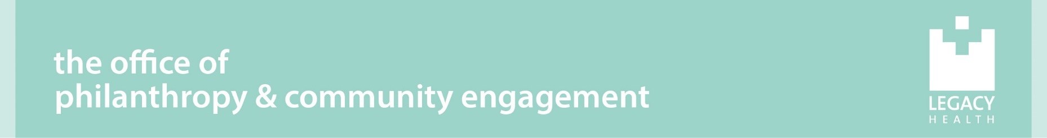

Meg Gadler Tripp Nursing Scholarship
Legacy Mount Hood Medical Center

We are pleased to encourage applications for the Meg Gadler Tripp Nursing Scholarship. These scholarships are made possible by donations in memory of Meg Gadler Tripp, RN, a beloved member of the Legacy Mount Hood Medical Center nursing team. In recognition of Meg’s passion for the nursing profession and her dedicated service as a nurse, leader, and mentor in the emergency department and intensive care unit, priority for the scholarships will be given to:

- Emergency Department (ED) and Intensive Care Unit (ICU) nurses who are pursuing advanced degrees (MSN or higher), including but not limited to Family Nurse Practitioner (FNP).
- CNA/CHTs or ED techs enrolled in a nursing program or completing pre-requisites for entry into a nursing program.
- RNs from other units pursuing an advanced degree (MSN or higher).

Number of Awards: | Two | Submission Deadline: | April 7, 2023
Amount of Award: | $2,000 | Recipients Notified By: | June 2023
 |  | Awards Checks Mailed: | August 2023

Eligibility
Candidates must meet the following criteria to apply:
- Current employee at Legacy Mount Hood Medical Center
- Accepted to/enrolled in a program leading to a nursing degree or completing pre-requisites for entry into a nursing program
- Demonstrate a commitment to serving Legacy Mount Hood’s patients and community

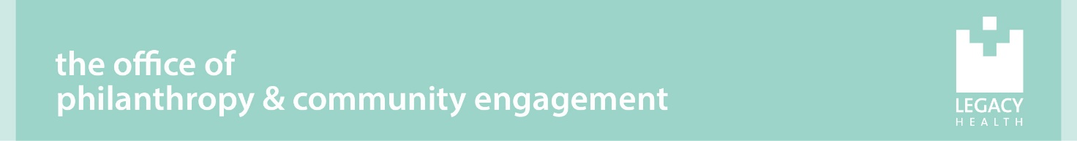

Meg Gadler Tripp Nursing Scholarship

Legacy Mount Hood Medical Center

APPLICATION

Applicants must submit the following items for evaluation by the selection committee via email to Kristine Krause, kkrause@lhs.org, or mail to Kristine Krause, The Office of Philanthropy, PO Box 4484, Portland, OR 97208, with the subject line “MH Meg Gadler Tripp Nursing Scholarship”, received no later than 5pm on April 7, 2023:

- Personal Statement of Financial Status
- Short Answer Essay Questions
- College Transcript for GPA Review, if currently enrolled
- One Professional Reference Letter

Candidates must type their application using this form to be considered.
Name
Address
Street City State Zip
Phone Email
Hospital department of employment
Position Title Supervisor Name
Are you full time or part time? Please list your FTE status:
Length of employment with Legacy Mount Hood Medical Center
Length of employment with Legacy Health ___________________________________________
Last completed degree
Name of educational institution funds are requested for
Program Name Cumulative GPA (if currently enrolled)
University Mailing Address:
City, State, Zip:
Student ID #: Term Start Date:
When did/will you start this program?
When do you expect to complete your degree?

Personal Statement of Financial Status:
How many credit hours do you intend to take in the 2023/2024 school year?
Tuition cost per credit hour: | x $
Expected total 2023/2024 tuition cost: | $
Expected LEAP reimbursement for these terms: | - $
Other scholarships or tuition assistance expected? | - $
Remaining balance: | = $

Please provide a brief statement generalizing your financial status. Consider how you plan to finance your education. If applicable, include details about your family's financial situation such as the number of family members currently pursuing post-secondary education or other important considerations. Please indicate if you have received other financial aid or scholarships, and from what source.

Please provide short answers to each question in about 100 words or less.

  - How do your career goals and this degree further the mission of Legacy Mount Hood Medical Center?

  - Why did you choose to work on this degree?

  - How would this scholarship assist you in obtaining your goals?

CERTIFICATION

I hereby certify that all the information provided in and with this application is true and accurate. Further, I certify that my own ideas and work product are set forth in this application.

Applicant’s Signature Date

Check List

□ Completed application – signed by applicant and dated.
□ Professional reference letter
□ Transcripts from Educational Institution, if currently enrolled.
Scholarship recipients will be notified in June 2023. Award checks will be mailed directly to the educational institution for tuition in August 2023.

